Dopa
A Generalized Android App for Memory Enhancement
Linganesan
Linganesan.12@cse.mrt.ac.lk
Undergraduate, University of Moratuwa

Abstract— This research mainly focused on finding the ways to adopt visual learning among Autodidacts to assess learning progress, predict performances, use memory techniques and rack potential issues. In order to achieve self-motivated and self-taught students in the future. This APP, 'Dopa' (derived from the hormone ‘Dopamine’, which is responsible for the reward-learning) introduces/reminds the user to utilize and ingrain Visualized learning as his/her second nature. Method of Loci (also known as Roman Room | Mind Palace | The Journey Method) is the widely used methodology visual based learning. There are existing such software, yet 'Dopa' specifically targets the Sri Lankan users as the pedagogy and other education mechanisms are considerably different in our settings. The ultimate vision is produce as many autodidacts as possible. Thus 'Dopa' deals with a special case, where the teachers are being the students, the autodidacts.
Keywords—Dopa; Method of Loci; Learning analytics; autodidct;

Introduction
Learning is a complex process. Advancements in IT has unwrapped fresh tools, techniques and even newer pedagogical perspectives to improve the learning process. One such area is Learning Analytics. Learning Analytics is all about improving the learning and its environment via the traces those are left behind by the teachers and learners, during the teaching/learning process.[2] Collecting more feasible traces simply results in more possible assistance. Thus the current efforts in LA focuses on E-learning environments where more traces could be obtained (higher amount and granularity).

Learning is ubiquitous. Paradigm shifts in the learning process had caused each and every significant leap in the human history. Education incorporates learning and thus the Education systems determine the betterment of any society. Here, I define Education as the process of transferring and facilitating the knowledge, skills and the habits. The emerging research area of Learning Analytics look for ways to improve learning outcomes with the assistance of Information Technology. It tends to use model of analytics to enrich the Education process & the Education systems. Learning analytics applies the model of analytics to improve learning. It collects the digital 'breadcrumbs' left by the student who has interacted with IT (computer) systems and then analyzes the records to find correlations between these interactions and learning outcomes. Such correlations (either associations) are presented back to the relevant user thus him/her could interact with the system in a better way in the future to produce better learning outcomes. The results could be presented to the 'teacher' as well as LA (Learning Analytics) focuses on pedagogy, the art & science of teaching.
In a special case the 'Teacher' and the 'Student' would be the same person, Autodidact-ism. Autodidact-ism is the next paradigm shift in the Education Domain. That is self-motivated and self-taught students are the future. With all these ever increasing knowledge sharing mechanisms and fluent access to this incredible amount of data, what else it takes to be an autodidact? Well, there should be something.

At present, particularly in Sri Lanka, the widely used mechanism for associating is the ‘Repetition’. This is proven to be one of the most inefficient, tedious and boring mechanisms for learning. Repetition inherently performs asymmetric association. For instance if we used repetition (mainly the auditory sense) to remember an event – year pair, then on some other day the event might remind the year, but the year might not remind the event due to the inherent mapping order. In a programming analogy we are using the Event as a pointer to the Year. There is technically no way from the year to trace the event. But our brain is complicated and uses several loops to perform this reverse order. May be not every time. The point is that the asymmetric approach is not the best way to go for. And it’s been proved very inefficient compared to some other methods.

Dopa is mainly focused on Autodidacts. Dopa tends to access powerful methods for significantly improving the power of user’s memory. A powerful memory will help user to succeed in school, in career, and in life. This application will asked the users to build their own mind palace (Loci). Users can practice with their mind palace and able view their improvements through a specific profiling. For an Example a student needs to memorize the order of Periodic Table Elements, Plants etc. She/he could enter the Keywords (in this case the Element name, Planet name etc.) and then use the system to associate with their already input Loci.This app will contain a theory section (study hall) to get to know the techniques and also users can customize the difficulty level of training that means number of words asked to the users for remember can be customizable.

User can used this app for his/her general purpose like remember notes for exams, speech, presentation, phone numbers, lists, in fact anything. In further developments this application will contains some Interesting memory games like strategies that to enrich indirect/passive learning.

The purpose of this research oriented project is to enrich the learning, related pedagogical approaches, effective teaching mechanisms, ICT in enriching Education and the General Education Sector in the Sri Lankan context via applying learning analytics practices. Thus having a thorough understanding regarding those concepts in Sri Lankan Context (a study on the existing learning/teaching processes and ICT usage) is very important and this section covers it to an adequate extent.

Literature Review
Method of Loci is a method of memory enhancement which uses visualization to organize and recall information. In this technique the subject memorizes the layout of some building, or the arrangement of shops on a street, or any geographical entity which is composed of a number of discrete loci. When desiring to remember a set of items the subject 'walks' through these loci in their imagination and commits an item to each one by forming an image between the item and any feature of that locus. Retrieval of items is achieved by 'walking' through the loci, allowing the latter to activate the desired item. [4] []

DOPA is not only a research project on educational memory training based on data mining, but also a development effort on bringing down the learning analytics concepts to the real word learning context. All the experiments and the outcomes above showed the effectiveness and usefulness on implementing a practical learning analytics system on secondary schools in Sri Lanka. Therefore DOPA has been initiated its development stage as an enterprise learning analytics system to make the effort successful and valuable to the targeted society.

This research identified the limitations and the development part tries to solve some of them. The future of this research is expected to find more on visual learning as the more data will be there after the successful completion of this project. And the user data source will grow with more detailed information with user management in the future. Also will be develop a desktop version with better interactive intuitive designs. [5] I have controlled the waste scope of this project due to time limitations. This research is more self-learning centered for the initiation purpose, but even the performance of teachers, school students, university academics also can be models in the same way.

system models
3.1 System Requirement
With this android application, user are allowed to create their own mind palace and build personalized profiles of each user. In each phone there will be one user stats are maintained. Users can practice various disciplines with the help of their mind palaces. Also user can keep their important notes according his/her mind palace.
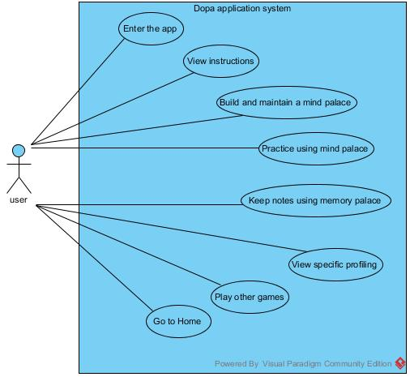
Nonfunctional requirements will be similar to any other typical mobile application. Such as performance, security and availability are crucial to make a better mobile application. For a mobile app maximize battery life by reducing computation and optimize for responsiveness are essential ones.

3.2 System Design
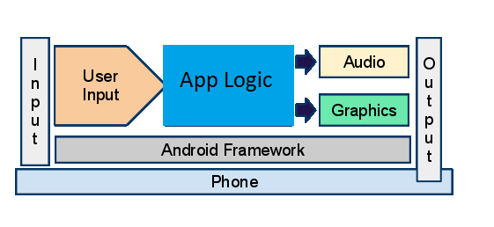
The user input is a touch even captured by the application which simulates the application logic module. The audio and graphics module includes the creation of the images and production of appropriate sounds.
Figure 1- Android Architecture diagram

Model-View-Controller architecture is used for the design of the application architecture, since it can be easily handled in Android. [9] MVC supports flexibility by separation of responsibilities.It helps separate the input logic, the application logic and the UI. The following diagram is the simplest logical representation of the model view controller concept.
In this model the application is divided into 3 separate components called model, view and controller. They are interconnected. Controller controls overall application. View get the support from model and controller in order to output to the user. Model is used to save the temporary data of the application.

The class diagram (figure-3) below represents the important classes implemented for the application with their operations and return types. The diagram also shows how each class is associated with other classes in the system. Each activity is represented as a class and the functions associated with the class are represented within.

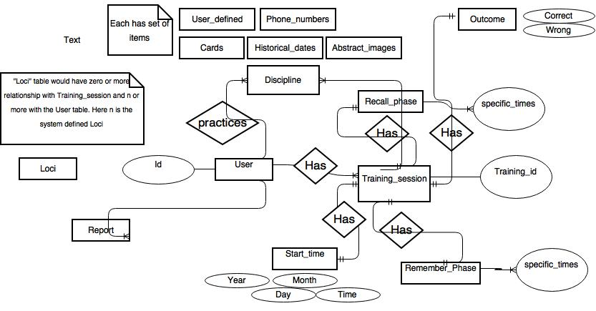
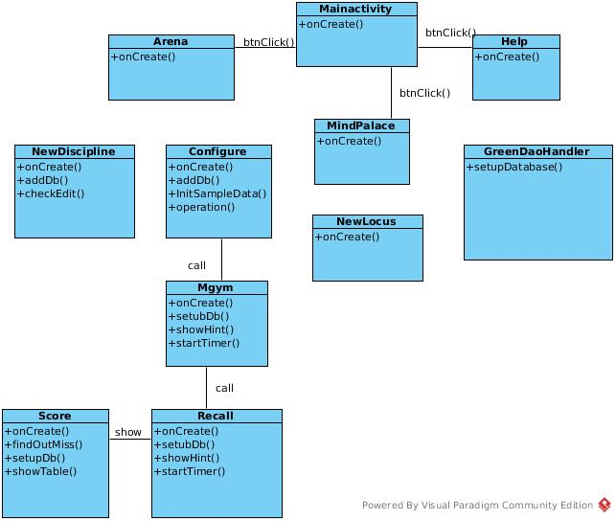
Figure 3- Class diagram

Also sequence diagram (figure-4) shows the interaction between the various classes and processes and the interaction order necessary to perform the functionality of the scenario. It showcases the classes involved in an interaction and the function calls and sequence of messages exchanged in that interaction.

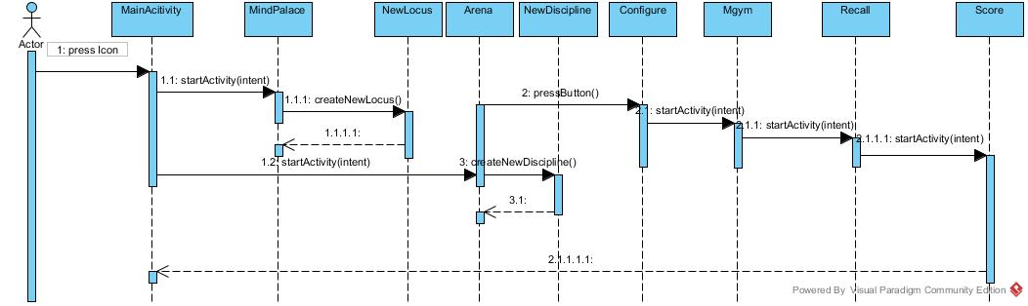
Figure 4- Sequence diagram
3.3 Database Design
The major information saved in this application is memory palace (Locus) and Discipline details. During the start-up of the application user required to build a memory palace and details are saved. Initially this data is saved in the MindPalaceDAO object of the application and subsequently these details are saved in the database which is hosted outside the application. During a practice session user can be request to view his/her memory palace, in order to memorize the words given in the session. I used GreenORM, an object-relational mapping (ORM) framework for Android is used for storing the Db map objects into a database [8]. It promises to put its focus on maximum performance. GreenORM takes over the responsibility of a Content Provider and offers methods to persist objects directly.
Figure 5- Db ER diagram

system implementation
4.1 Implementation Procedure (Android)

I have implemented this application using the Android and Java languages. Java is used as the main implementation language.The implementation in android starts with creating an new android project in Android Studio which creates separate folders for source code, resource files like images, xml files representing user interface layouts, gen folder that transforms each individual element names in resource file to unique identifiers that would be referred by the android system and other folders.
Google's Android Studio makes creating native Android apps very easy. Also provide Better UI in designing and coding. Dopa is designed from a user point of view. The user friendly design helps the users in accomplishing their task with ease. Attempts have been made to keep the design simple and understandable. The screens were designed in XML and the application logic was written in Java. An Activity is an application component in android providing a screen with which users can interact in order to do something. The activity with some of the resource files represents the user interface in android [10]. The dopa contains several activities to show different screens within our application as follows: MainActivity, Arena, MindPalace, Help, NewLocus, NewDiscipline, Configure, Recall, Arena and Score.
Android has a built in database engine SQLite which helps applications to do database operations. Any database created by an android application is accessible by name to any class within the application but not outside the application. The database used is SQLite where all the information related to dopa is stored. In Database design I used an android ORM framework tool called GreenORM [8]. It is a complete code generation which allows me to generate my data model without having to worry about creating each table and managing the column names and indexes.
4.1.1 Materials

In the practice session, user has to practice his/her mind palace with limited number of random words. To create a list of random words I used a list of words file in a text file format (.txt). It contains 1000 words and 53KB in size and I stored that file in asset folder of my android project. This file will be called by program when user want to practice with random words.
4.1.2 The Algorithm

For the create mind palace user function will receive the user inputs and it will be stored temporarily and after that it will be stored permanently in the database. Use mind palace function gets the mind palace details as the user input. User profiling function call updates when user played a session and then it will show the overall progress to the user.

4.2 Main Interfaces

The project involved analyzing the design of few applications so as to make the application more user friendly. To do so, it was really important to keep the navigations from one screen to the other well-ordered and at the same time reducing the amount of typing the user needs to do. Hints are given to help the user in giving the correct input. In order to make the application more accessible, the android version had to be chosen so that it is compatible with most of the Android devices. Hence Android 4.1.2 Jelly Beans version was chosen.

Screen shots of the user interface design are follow. They are designed carefully, in order to build an application with the improved usability.

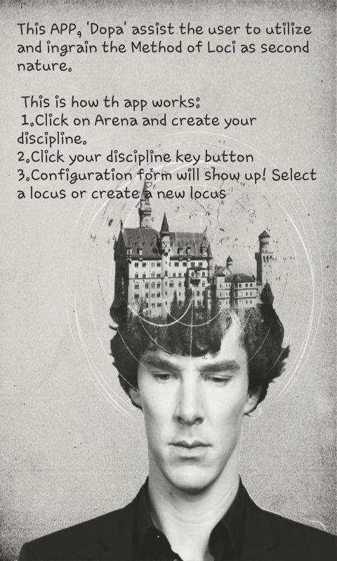
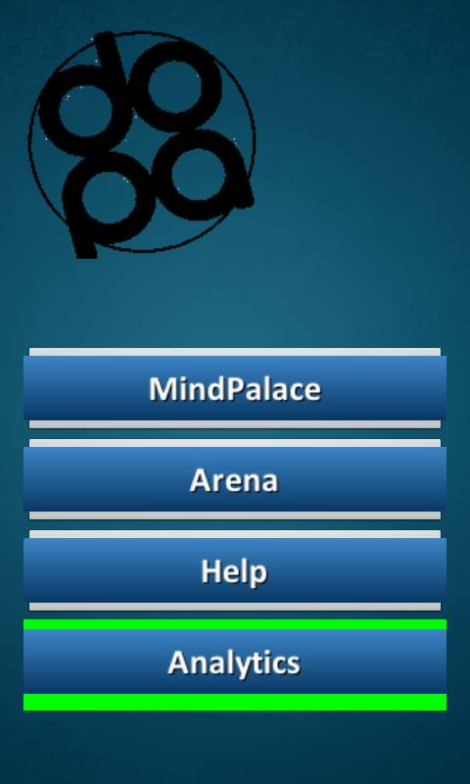

Figure 7-Dopa helppage

Figure 6-Dopa homepage

Press back key in your mobile to see the Dopa home page.

- Click on Mind Palace.
- Click on Add New Locus- Add your locus (locus is a location where you are very familiar with.)


Example 1:
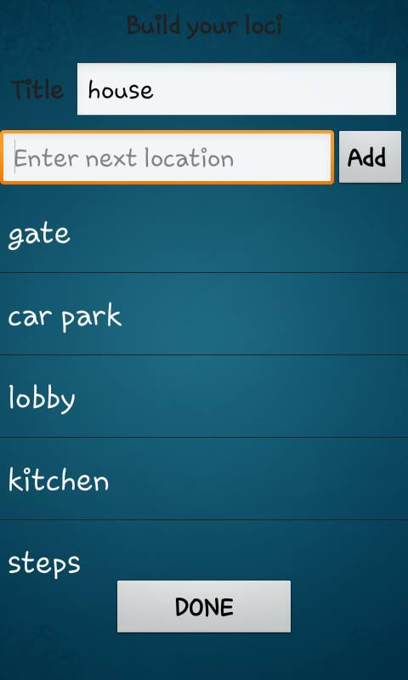
Add “house” as your locus. Add locus items.

Note: Duplicates in Locus Name, Discipline name, Locations and Discipline Items are checked.
Press back to see the Dopa homepage.
Click on Arena
Click on New Custom Disciplene
Add disciplene Name.

Disciplene is the list what you are going to memorize by using Method of Loci.
Add disciplenes(whatever you want to memorize) If you want the list in an order,Make sure you want the list in the order.
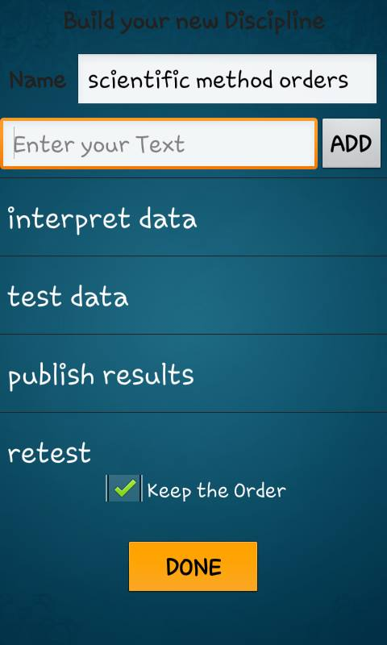
Click on Keep the Order box.

Press Back key to see the Dopa homepage. To select the discipline click on Key image.

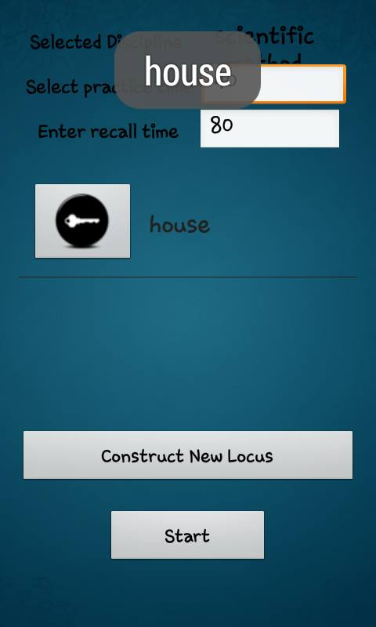
You will see following image. Image contains three major parts: selected discipline, practice time and recall time. User can edit all these three options. User can minimize or maximize practicing time by typing manually in the given space. As well as the recall time.

Already user has declared the loci as “house”. If the user wants to change the loci, there also an option called “Construct New Locus”. Here user can construct new locus instead of using “house”. Before pressing the “Start” button, user has to make sure about her/his Loci. User must press on selected Loci “key image”.
After pressing Loci image,
Selected Loci will pop-up on the screen.
Start button will take the user to practicing page.

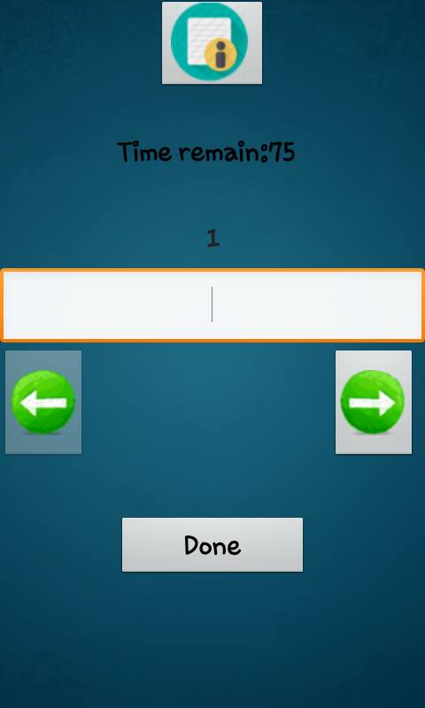
Practicing page.
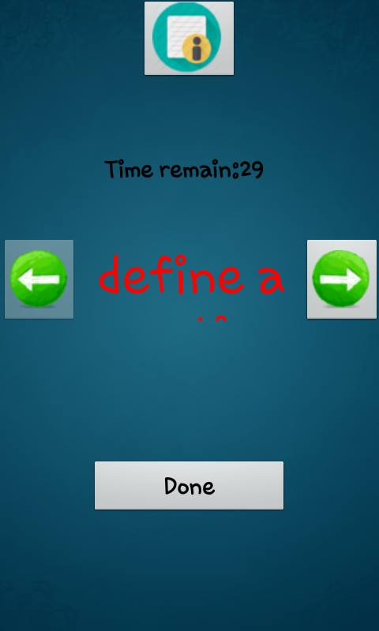
Practicing page contains navigation bars, where user can navigate (previous and next) and practice each discipline.
Practicing page also runs a timer. Which is helpful to calculate the practicing and recalling time in the feedback phase.
Practicing page is the place which connect user’s loci with the user’s discipline. If you click on the top image you can make sure what the loci for your selected discipline is.
Ex: Discipline to remember is scientific method list.
Locus to connect the discipline is “house”
Discipline list: Scientific method order.
- Define a question
- Observe
- Hypothesis
- Test hypothesis
- Interpret data
- Test data
- Publish results
- Retest
Given Loci list: House.
- Gate
- Carpark
- Lobby
- Kitchen
- Steps
- Hall
- Room1
- Room2

Now user can test the correlations of these, if the user is in the navigation of Hypothesis and if he/she press the correlation button, he/she will get a pop-up message identifying the discipline with the correlated locus.
After pressing “Done” button user will take recall phase. This page is same as the practicing page. This page also will contain navigation buttons. And the correlation image button. Then the items will be ordered.

When user clicks on the correlation button user will see the locus correlation which is connected to the discipline.
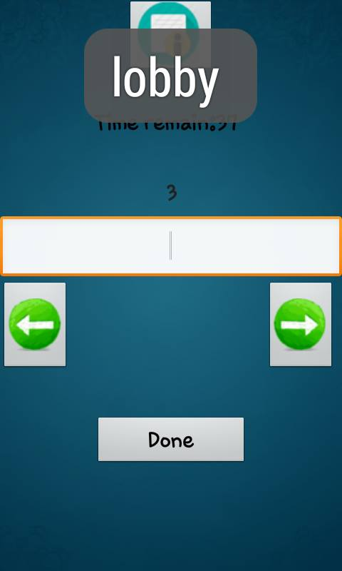
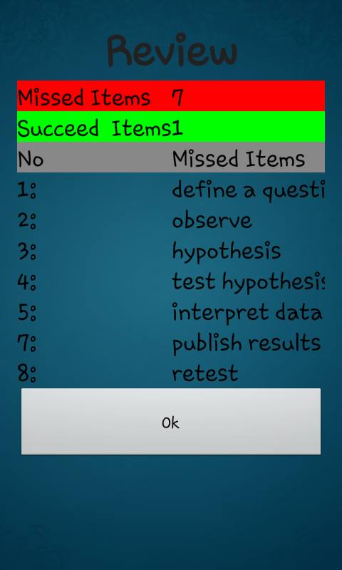
After typing the correct answers using the correlation hind button or typing without any hinds, user will get to the “Review report” page. Which will appear alike the following image.

Review will calculate Missed Items and Succeed Items. Also the report will correlate each locus with each discipline as in the above image.
After pressing Ok button, in the first attempt user will take to the Dopa home page. After finishing at least three attempt Analyzing page will be turned green.
And user will suggested to get an option which saying “Sync discipline to get reports”. If the user press the “key image” button, user will take to the intelligence feedback page.
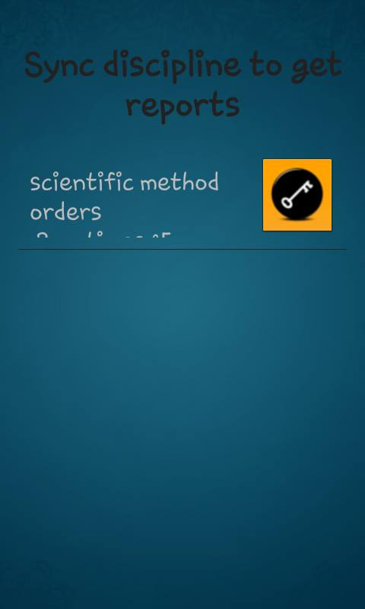

system testing and analysis
The Android SDK consists of a virtual mobile device emulator that helps to test the application without having a physical device as it provides all the functionalities of a typical physical mobile device. Logging and debugging in android is done with the tool Android Device Bridge (ADB)[3]. ADB is one of the useful tools that come with the Android SDK. The system level logs and user defined logs are shown when ‘adb logcat’ command is executed while the application is running in emulator or in the device. Also, the Dalvik Debug Monitor Server [DDMS] which comes integrated with Android plugin for Android Studio helps to read the log messages for a specific emulator instance running our application. ADB tool also provides the shell access to the android system of the device connected to system via USB cable. This tool provides access to SQLite database and the tables created and can be used to display the entries in the table.

Unit Testing
In Unit testing each independent unit is tested separately, by isolating it from the remainder of the code to ensure parts of the code are working properly. I have done unit testing using the JUnit testing mechanism and I have done the integration testing using the Robotium library. JUnit provides several assertion-based testing, such as assertNull(), assertEquals(), assertTrue(), and assertSame(). If any of these returns false, then the test case is considered as failure. Also Integration testing is done by giving the input details programmatically and checking the activities.
Some of the test results for the Unit testing is given below,

User Interface Testing
Test Case | Expected Result | Result
Check the locations on the Locus(MindPalace) | No duplicates are allowed | Pass
Check the locus name | Locus name should not be null | Pass
Check Number of locations in Locus | Size of Locus should be equal or greater than size of Discipline | Pass
Check practice time | Not to be null | Pass
Check each Locus’s location with loop | Each location should properly assign to each item in discipline | Pass
Check Timer time | Timer should be end to practice time. | Pass
Check each Locus’s location with loop | Each location should properly assign to each item in discipline | Pass
Check Timer time | Timer should be end to practice time. | Pass
Check review list | User missed items should be shown. | Pass
User Interface (UI) testing verifies a user’s interaction with the software. UI testing ensures that the objects within the UI function as expected and conform to corporate or industry standards. I used Espresso, by install the Android Testing Support Library. The Espresso API is located under the com.android.support.test.espresso package.

Compatibility Testing
Variations in software versions, configurations, display resolutions, servers and Internet connect speeds can heavily impact the application behavior. Different specifications of devices can also make the applications to behave differently. To check the device compatibility, the application is tested in the both Android tablet and smart phone. Also reporting test execution results is very important part of testing, tester should make a complete test results report which includes the Test Pass/Fail status of the test cycle.

Conclusion and future work
The application has been designed, implemented and tested with real devices with users successfully. The project helped in understanding the challenges involved in developing an android application for android phones and tablets, the ways to overcome them and in better understanding the complexities of mobile application development. The project also helped in understanding the value of designing the components of overall application before implementing them. The project has also taught me programming skills and refining the design and implementation logic of the software at every phase of the development life cycle to improve the overall performance of the application.
The vision is to help as many people to become autodidacts. One major channel is to introduce/remind the users the visual based learning methodologies. At present the Dopa APP is only concerned of the Journey method (Mind Palace/Roman Room/Method of Loci), which is the mostly used Visual based learning method. Dopa being a generic tool that anyone case use to memorize any set of things, as long as they could be entered as Texts/Keywords.
Followings are the future plans and expected features
- Generalize input types (images/photos, sound etc.)
- More interactive and attractive UI, better UX In built disciplines, such as Cards
- Challenges and comparisons
And incorporating Educational Data Mining (either Learning Analytics) would add a great value.
- Collect granular data such as number of attempts/time per item, correlations, isHintUsed etc.
- Use Association Rule Mining to find out patterns, for instance which Locus is handy, which Disciplines are related, which set of Discipline-Locus is performing well in tandem
- Use Classification to rate user (after collecting results from various users)
Use clustering to identify ‘unsupervised’ outcomes (for a criteria which gender, demographic, which discipline etc.)

Acknowledgment
This project is a third year software engineering project carried out under the supervision of Dr. Indika Perera and Dr. Dulani Meedeniya. Their constant guidance and frequent reviews have assisted a lot in completing this software engineering project and completing it well.

References
- G. Eason, B. Noble, and I.N. Sneddon, “On certain integrals of Lipschitz-Hankel type involving products of Bessel functions,” Phil. Trans. Roy. Soc. London, vol. A247, pp. 529-551, April 1955. (references)
- 1st International Conference on Learning Analytics and Knowledge 2011. [Online]. https://tekri.athabascau.ca/analytics/
- W.W Palagolla and Nisha Curl Kumari, "Use of ICT among secondary schools in the North Central Province of Sri Lanka," Faculty of IT, UOM, SriLanka, 2009.
- Fassbender, E., and W. Heiden. "The virtual memory palace." Journal of Computational Information Systems 2.1 (2006): 457-464.
- Harman, Joshua. "Creating a memory palace using a computer." CHI'01 Extended Abstracts on Human Factors in Computing Systems. ACM, 2001.
- Vogel, L. (2009). Android Development Tutorial. Retrieved August 2, 2011, from vogella:http://www.vogella.de/articles/Android/article.htmlhttp://developer.android.com/index.html
- Samy, M. (2010). Android. Retrieved August 5, 2011, from CodeProject: http://www.codeproject.com/KB/android/AndroidSQLite.aspx
- Vivien Dollinger, Markus Jungiger. GreenORM – Android ORM for SQLite, 2013. From : http://greendao-orm.com/features/
- widgetguide. (2010). Retrieved October 27, 2011, from Droiddraw: http://www.droiddraw.org/widgetguide.html A basic game architecture. (2010, July 26).
- Android Architecture Description http://www.android-app-market.com/android-architecture.html
- Wikipedia. Retrieved June 2nd, 2015 from the Wikipedia Wiki: http://en.wikipedia.org/wiki/Method_of_loci
- Art of Memory. Retrieved June 2nd, 2015 from the ArtOfMemory.com: http://artofmemory.com/
- Yates, F. A. (1966). The art of memory. United Kingdom: Routledge and Kegan Paul
- Mustaﬁzur Rahman, Md. Raﬁul Hassan, Rajkumar Buyya, “Jaccard Index based Availability Prediction in Enterprise Grids”, Department of Computer Science and Software Engineering The University of Melbourne, Victoria 3010, Australia, 2010.

